Campus Connect

# PROJECT PHASE– II SYNOPSIS

**BACHELOR OF TECHNOLOGY SEMESTER - VIII**

COMPUTER SCIENCE & ENGINEERING

SUBMITTED BY

## Mr. RUSHIKESH ANIL KATKAR (2065451242034) Mr. SHUBHAM POPAT GHADGE (2065451242044) Mr. NISHANT VITTHAL DHUMAL (2065451242022)

UNDER THE SUPERVISION OF

**PROF. Pathak P. A.**



# ARVIND GAVALI COLLEGE OF ENGINEERING SATARA

**2023 – 2024**

# CERTIFICATE

This is to certify that the synopsis entitled “**Campus Connect**” is a bonafide work carried out by,

Mr. Rushikesh Anil Katkar. Mr. Shubham Popat Ghadge. Mr. Nishant Vitthal Dhumal.

under our supervision during the academic year 2023-24 and submitted to the faculty of Computer Science & Engineering, AGCE, Satara in partial fulfillment of the requirements for the final year of Bachelor of Technology in Computer Science & Engineering.

Mr. Amol Barge. Prof. Pathak P.A

Alumni Mentor Guide

Mr. Gujar V. B Dr. Bhosle V.K

Project Co-Ordinator HOD

Dr. Mirajkar. G. S Dr. Pharande V. A.

Dean R & D Principal

|  |  |
| --- | --- |
| **Content** | **Page no.** |
| 1. Introduction | 2 |
| 2. Objective and Scope of the Project | 3 |
| 3. Literature Review | 4 |
| 4. Methodology | 7 |
| 5. Hardware Required | 8 |
| 6. Software Required | 9 |
| 7. Estimation | 10 |
| 8. Project Timeline | 11 |
| 9. References [IEEE Format] | 12 |

## Introduction

* Campus Connect is a platform for college students and college training and placement officer (TPO) of college which connect them with industry.
* Web site has the two login:

### College students

* + **College TPO**
  + **Company**
* Students have to make their profile on websites which contain their all information in academics, their skills and other information.
* College TPO can view their profiles and share their profile to the industrial experts and different companies for during On campus and Off campus placement round. So, company HR get idea about students before interview.
* **Companies can log in to the platform to access student profiles, review their qualifications, and directly post new job vacancies. This ensures that students are notified of opportunities that match their skills and interests, streamlining the recruitment process for both companies and students.**
* Website also having the prediction system for students to predict their preparation for interview and specific technology. To predict this we use Logistic Regression algorithm for prediction
* Student can prepare for interviews on same website by solving the tests for that we create a online test platform on same website.

## Objective and Scope of the Project

### OBJECTIVE

* To develop a website for students. This platform is mainly for student and college TPO which helps them to find out perfect company according to their skills and experience.
* To build platform for the students which reduce much time of students to find out company according to their skills. It is difficult process that analyze one by one company according to our marks and it is lengthy process. It consume much time. For reduce much time of student for find out company easily according to their percentage criteria we have this digital platform.
* To create a prediction system for students which can predict how much preparation of student is done and where to improve.

### SCOPE OF THE PROJECT

* 1. Reduce the time of student for find out company
     + It is time consuming process to analyze each company and their criteria. It takes much time of student. By using this platform student easily find out company.
  2. Recommend best company for students

* + - Sometimes student cannot find out company according to their skill or marks. Students are able to apply much better company according to their marks but due to lack of information or guidance they cannot apply so this platform recommend best company for students.

C) **Efficient Shortlisting Process for Companies**

* + - Sometimes Companies can access a comprehensive database of student profiles, complete with detailed academic records and skill set. Using advanced searching tools, companies can quickly shortlist candidate that meet their specific criteria.

## Literature Review

|  |  |  |  |
| --- | --- | --- | --- |
| **Author Name** | **Paper Name** | **Publication Year** | **Technology Used** |
| Sonal Kureshi | The IUP journal of marketing management, Vol.9 Nos 1& 2 | 2010 | This paper revives the literature on product placements to develop three frameworks for three frequently used media.. |
| Vandana Sood | Conceptual and Managerial implication | 2010 | The usage placements is increasing across media making it essential for us to understand its effect on the audience |
| Nilesh Rathod | As Interactive online Training and Placement system. | 2013 | College talent placement system at providing the facility to automate and simplify the process of registration and list generation of eligible students for placement. |

|  |  |  |  |
| --- | --- | --- | --- |
| **Author Name** | **Paper Name** | **Publication Year** | **Technology Used** |
| Shilpa Hadkar | College collaboration portal with training and placement | 2014 | The project will indicate manual work and maximize optimization, abstraction and security. Students will get notify when TPO’s upload study material or any campus drive information through the system. |
| Rampalli Paya, Ganesan Palanisamy,  S.K.V Jayakumar | Mediterranean journal of social sciences | 2015 | Campus recruitment is the process by which the corporate recruit students who are about to graduate from the educational institution. |
| Suraj Gupta | “Recruitment system with system  prediction” | 2021 | This concept is used to determine in next step to determine or predict employee placement based on their characteristics. |

1. **Methodology**

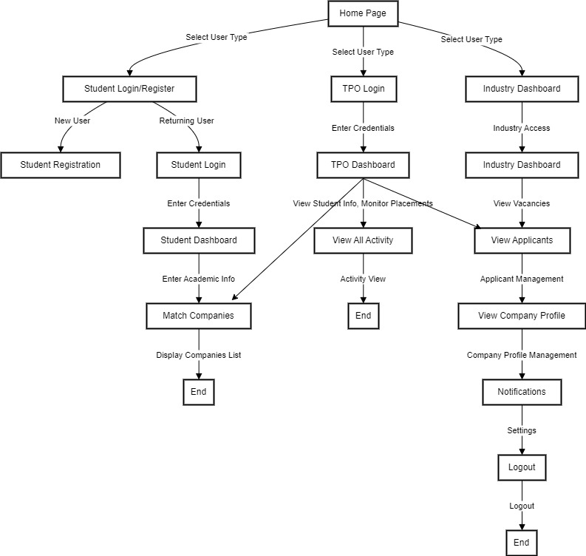

Fig 1: FlowChart

## Hardware Required

### Web Server

* + 2 GB RAM
  + 80 GB Hard Disk
  + 1.6 GHz Processor

## Software Required

### Server

* + - * Nodejs environment for backend
      * Express Framework
      * Mongo DB
      * Atlas

### Client

* + - * Operating System- Windows XP 2000 & onwards
      * Internet connection

### Development

* + - * VS code
      * Html
      * Css
      * Java script
      * React

## Estimation

|  |  |  |  |
| --- | --- | --- | --- |
| **Sr.**  **No.** | **Particulars** | **Cost** | **Remark** |
| 1 | Operating system | 12000 | (Windows XP,7,8,9,10,11) |
| 2 | Development | 15000 | Includes laptops, software’s etc. |
| 3 | Deployment and Hosting | 20880 | Server and domain name |
| 4 | Total Cost | 47880 | Approximately |

1. **Project Timeline**

**1 Sep 2023 to 15 Oct 2023**

Domain & Title of Project

**15 Oct 2023 to 15 Nov 2023**

Requirement Analysis &Information Gathering

**15 Nov2023 to 15 Dec 2023**

Filtering company according to user criteria

**15 Dec 2023 to 15 Jan 2024**

Campus job section for student and company

**15 Jan 2024 to 15 Feb 2024**

Select/ reject recruitment process completed

**15 Feb 2024 to 15 March 2024**

Email service added successfully

**15 March 2024 to 15 April 2024**

Email sending for new job and new company adding/ job

**15 April 2024 to 15 May 2024**

Download resume task completed

**15 May 2024 to 30 May 2024**

Demonstration and Documentation

## References

1. Sonal Kureshi The IUP journal of marketing management, Vol.9 Nos 1& 2 2010-05-26
2. Vandana Sood Conceptual and Managerial implication “The usage placements is increasing across media making it essential for us to understand its effect on the audience”. 2010
3. Nilesh Rathod As Interactive online Training and Placement system “College talent placement system at providing the facility to automate and simplify the process of registration and list generation of eligible students for placement”. 2013
4. Shilpa Hadkar College collaboration portal with training and placement “The project will indicate manual work and maximize optimization, abstraction and security. Students will get notify when TPO’s upload study material or any campus drive information through the system”. 2014
5. Rampalli Paya, Ganesan Palanisamy, S.K.V Jayakumar Mediterranean journal of social “Campus recruitment is the process by which the corporate recruit students who are about to graduate from the educational institution”. 2015.
6. Suraj Gupta “Recruitment system with system prediction “This concept is used to determine in next step to determine or predict employee placement based on their characteristics” 2021.

.

.